CALL FOR ARTISTS
City of Peshtigo Storm Drain Art Program
Downtown Peshtigo, Wisconsin

The City of Peshtigo is seeking artists to participate in a new downtown storm drain art project focused on conservation, clean water awareness, and community pride.

This project is centered around the message: Only Rain Down the Drain
Storm drains carry runoff directly to local waterways. This project will use painted storm drains to help educate the public while adding bright, creative, and meaningful artwork to the downtown area.

Project Scope

The City is planning to complete approximately four (4) to six (6) storm drains this year as part of the first phase of the program.

Student Involvement

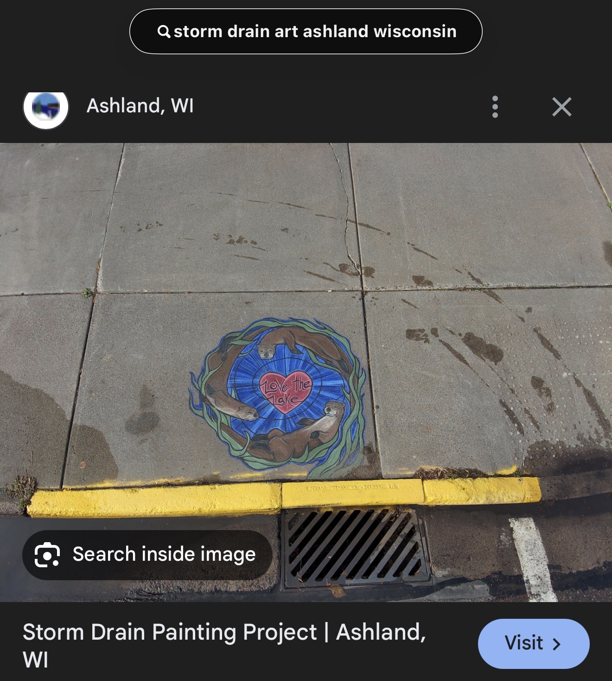
The City hopes to set aside at least two storm drains for student-based designs or student participation from local schools, depending on interest, supervision, and final project planning.

Who Should Apply

We are looking for:
- Local and regional artists
- Community artists
- Muralists
- Art teachers or artist-educators
- Artists with outdoor painting experience
- Artists interested in conservation-themed public art
Artists from the Peshtigo, Marinette, Menominee, and Oconto area are especially encouraged to apply.

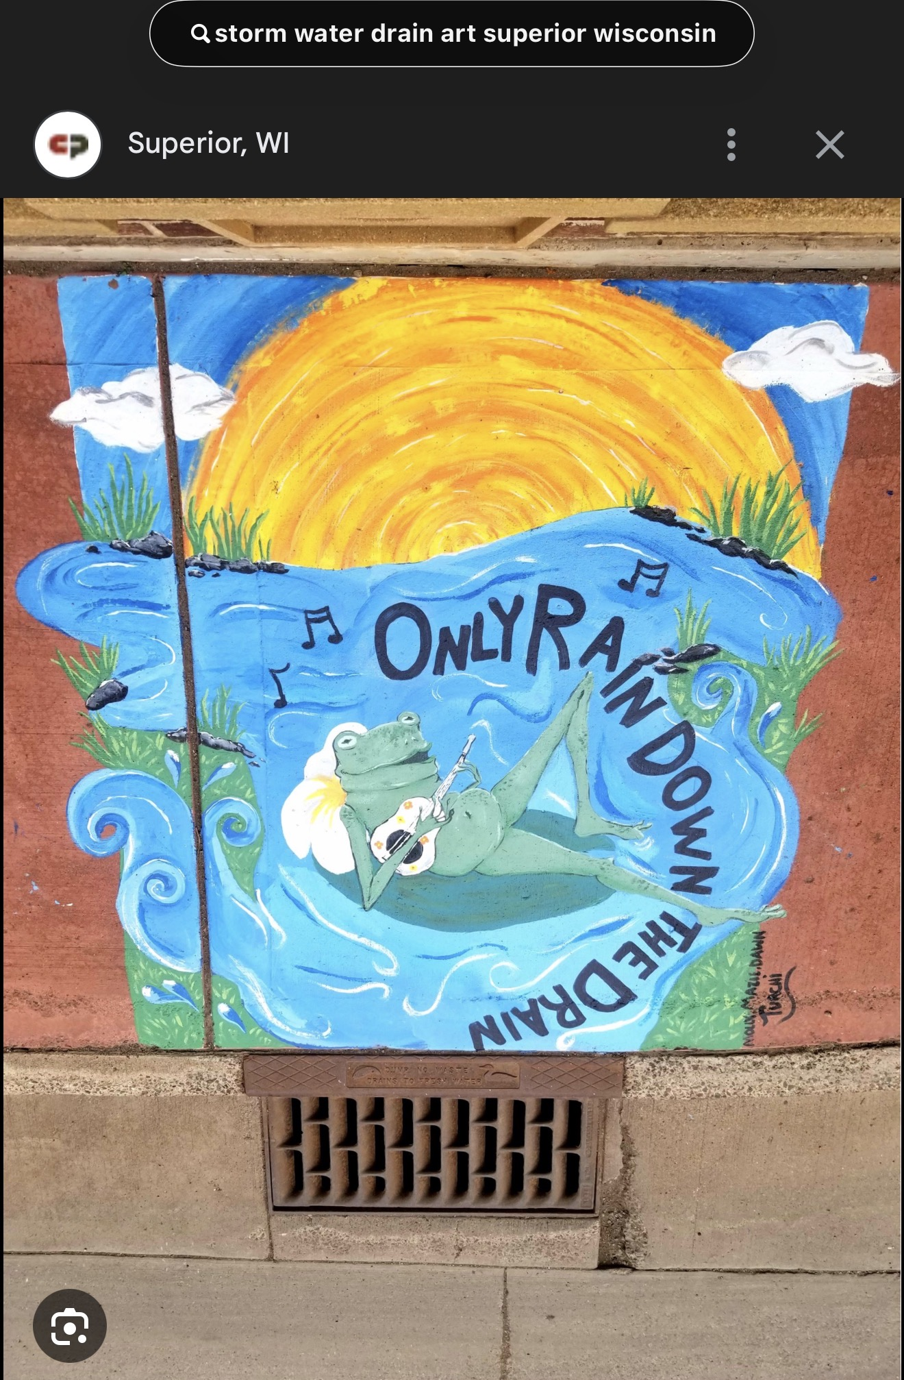
Required Theme

- All artwork proposals must relate to:
- Only Rain Down the Drain
- Water conservation
- Clean water education
- Animal or wildlife conservation
- Stormwater awareness
- Protection of rivers, lakes, wetlands, and habitats

Examples of Appropriate Design Elements

- Fish and aquatic life
- Frogs, turtles, birds, dragonflies, butterflies, and pollinators
- Native plants and river vegetation
- Rain drops, river imagery, and water movement
  - Child-friendly conservation imagery
- Community pride elements tied to Peshtigo outdoor spaces
- Messages about keeping trash and chemicals out of storm drains

Design Expectations
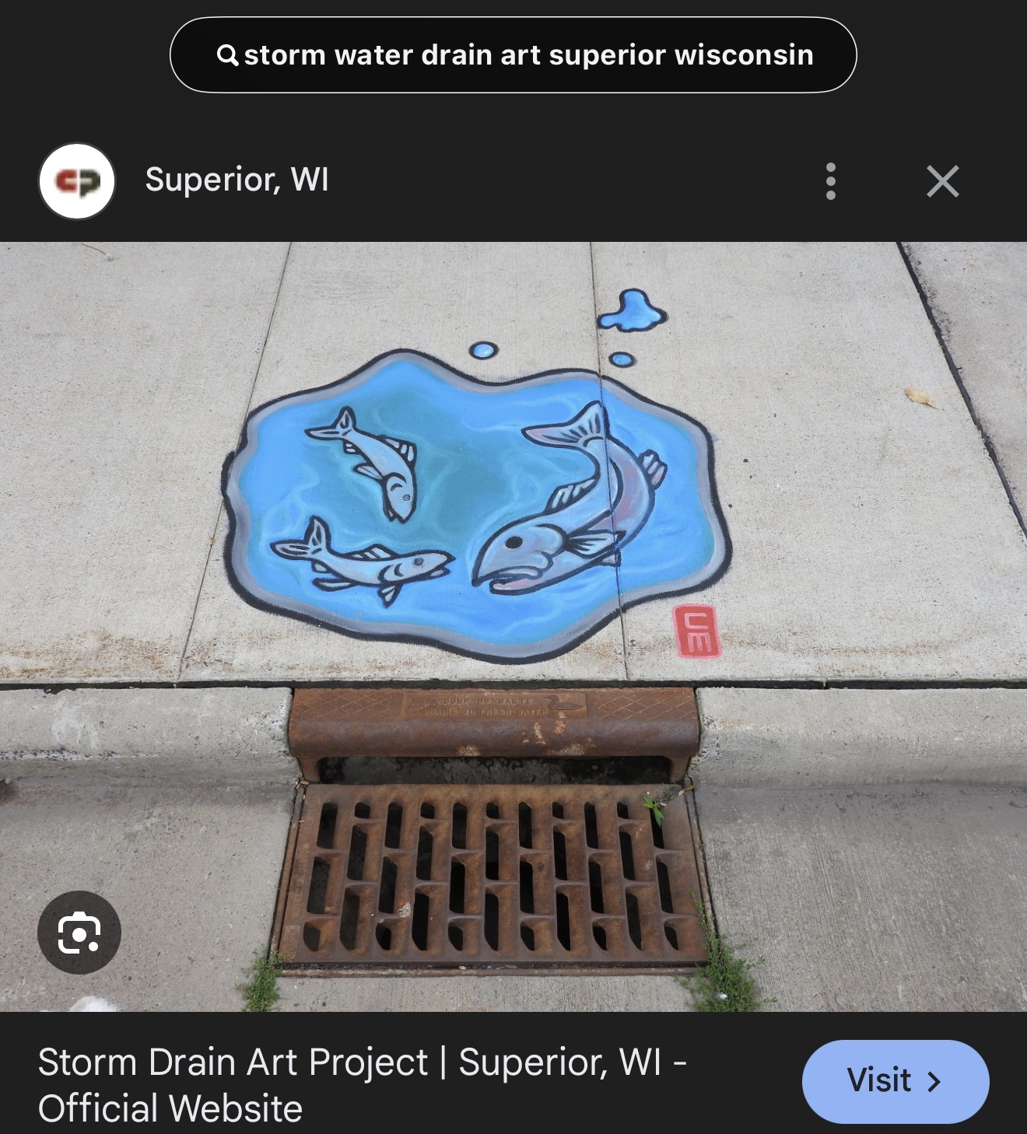
Proposed artwork should be:
- Family-friendly
- Original
- Easy to understand in a public setting
- Bright, visible, and suitable for outdoor conditions
- Respectful of the educational purpose of the project

Materials

The City intends to consider Earth & Flax Viking linseed oil paint among the materials for this project, along with other products needed for prep work, application, and long-term durability.
Because this product is intended to be mixed well and applied in thin coats on a clean, dry surface, the City expects to put together a basic starter supply kit for participating artists. That kit may include both shared materials and artist-use supplies depending on the number of selected projects.

Selection Process

Applications will be reviewed by the City. The Streets and Drainage Committee will review and vote on up to six selected images/design concepts to move forward as part of this year’s project.

Tentative Timeline
- Submission deadline: June 8, 2026
- Design review and selection: Expected later that week, following the application deadline
- Painting start: Expected in July - August, weather permitting
- Painting schedule: Work may be staggered so artists can share supplies and so the City can manage locations more efficiently

Photos and Publicity

By applying, artists understand that the City may photograph the design, installation process, and completed work for public information purposes. Photos may be shared on the City of Peshtigo website and in related City communications.

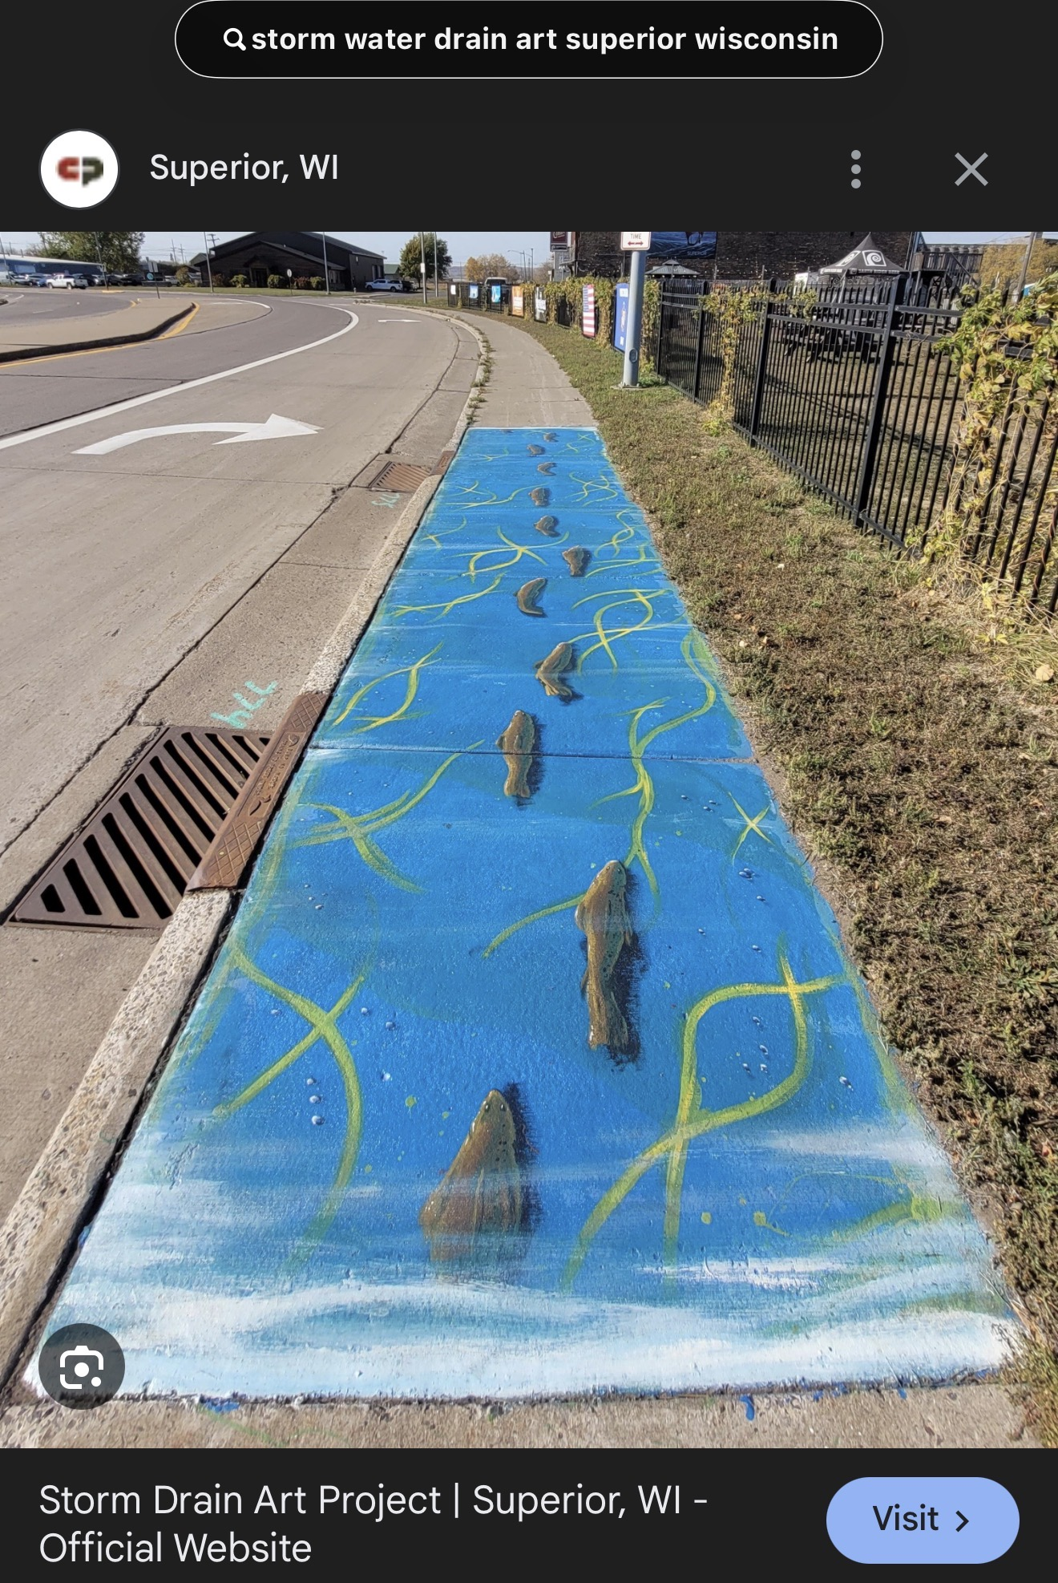
What to Submit

Artists should submit:
- A completed application form
- Basic contact information
- A short artist statement or background
- A brief description of the proposed idea
- A rough sketch or concept drawing
- Samples of previous work, if available

Questions or Submissions

Please send completed applications or questions to:
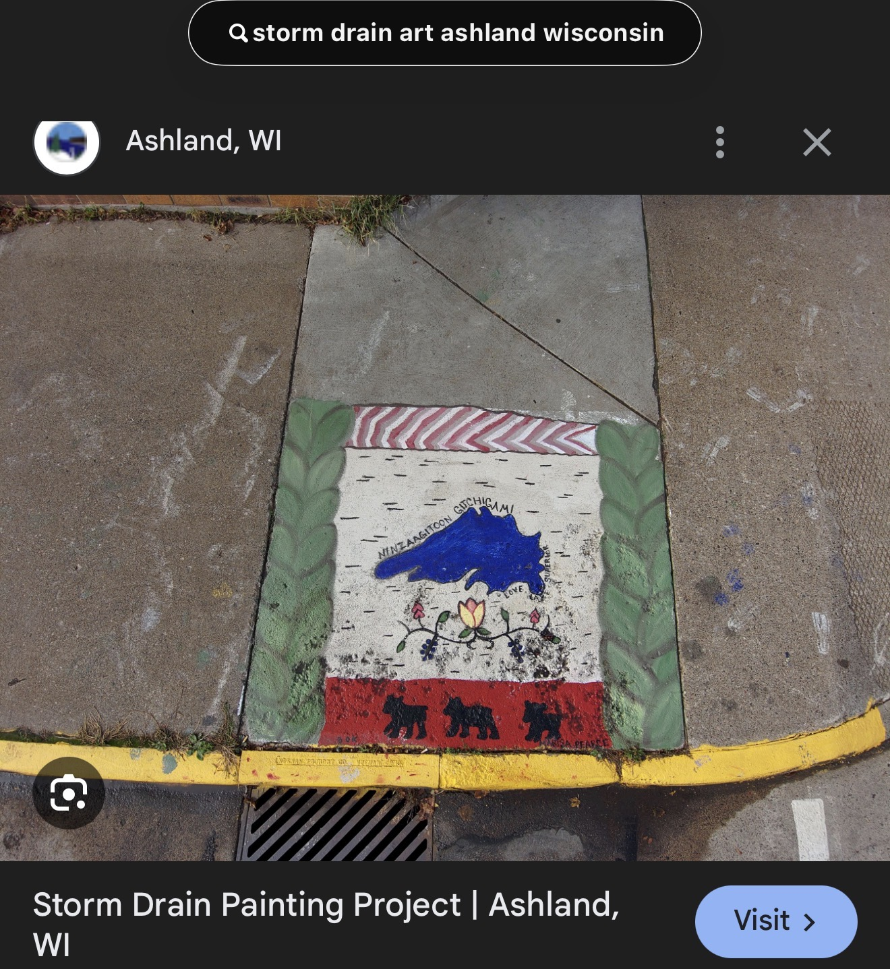
Katie Berman
Mayor, City of Peshtigo
katieb@ci.peshtigo.wi.gov

City of Peshtigo Storm Drain Art Program
Artist Application
Applicant Information
Name: _______________________________________________________________________
Artist / Business Name, if applicable: ______________________________________________
Address: _____________________________________________________________________
City / State / Zip: ______________________________________________________________
Phone: ______________________________________________________________________
Email: ______________________________________________________________________
Website / Social Media / Portfolio, if available: ______________________________________
Do you have samples of previous artwork to submit?
☐ Yes, attached ☐ Yes, link provided: _______________________ ☐ No / Not applicable
Prior art experience is welcome, but not required. The City encourages applications from community members, students, teachers, local artists, and anyone with a creative conservation-based idea.
Artist Background / Interest in the Project
Please share a short summary of your background, interest in art, connection to the community, or why you would like to participate in this project.

Conservation Theme Statement
All proposed designs must connect to the project theme: Only Rain Down the Drain.
Designs may also relate to clean water, stormwater awareness, wildlife, rivers, lakes, wetlands, native plants, pollinators, or keeping trash and chemicals out of storm drains.
Please briefly describe how your idea connects to the project theme.

Public Art / Outdoor Painting Experience
Please describe any experience you may have with murals, outdoor painting, concrete surfaces, student art projects, public art, or similar work.
If you do not have prior experience, that is okay. You may simply write “No prior experience” and share anything else you would like the City to know about your interest or ability to complete the project.

Sketch and Concept Page
Proposed Design
Design Title: __________________________________________________________
Short Design Description:

Would you be open to adapting your design based on location, size, safety considerations, or City feedback?
☐ Yes ☐ No ☐ Maybe / I would like to discuss it
Rough Sketch / Concept Space
This does not need to be perfect. A simple drawing is fine. The City is looking for the general idea, layout, color scheme, and message of your proposed design.
Sketch Notes / Color Ideas / Message Elements:

Please attach a sketch of your concept for the storm drain artwork.

Maintenance / Touch-Up Acknowledgment
Because this artwork will be outdoors and exposed to weather, selected artists should understand that the City may contact them in the spring for touch-ups for the first couple of years after the project is completed. The goal is to help keep the artwork bright, visible, and in good condition for the community.
☐ I understand

